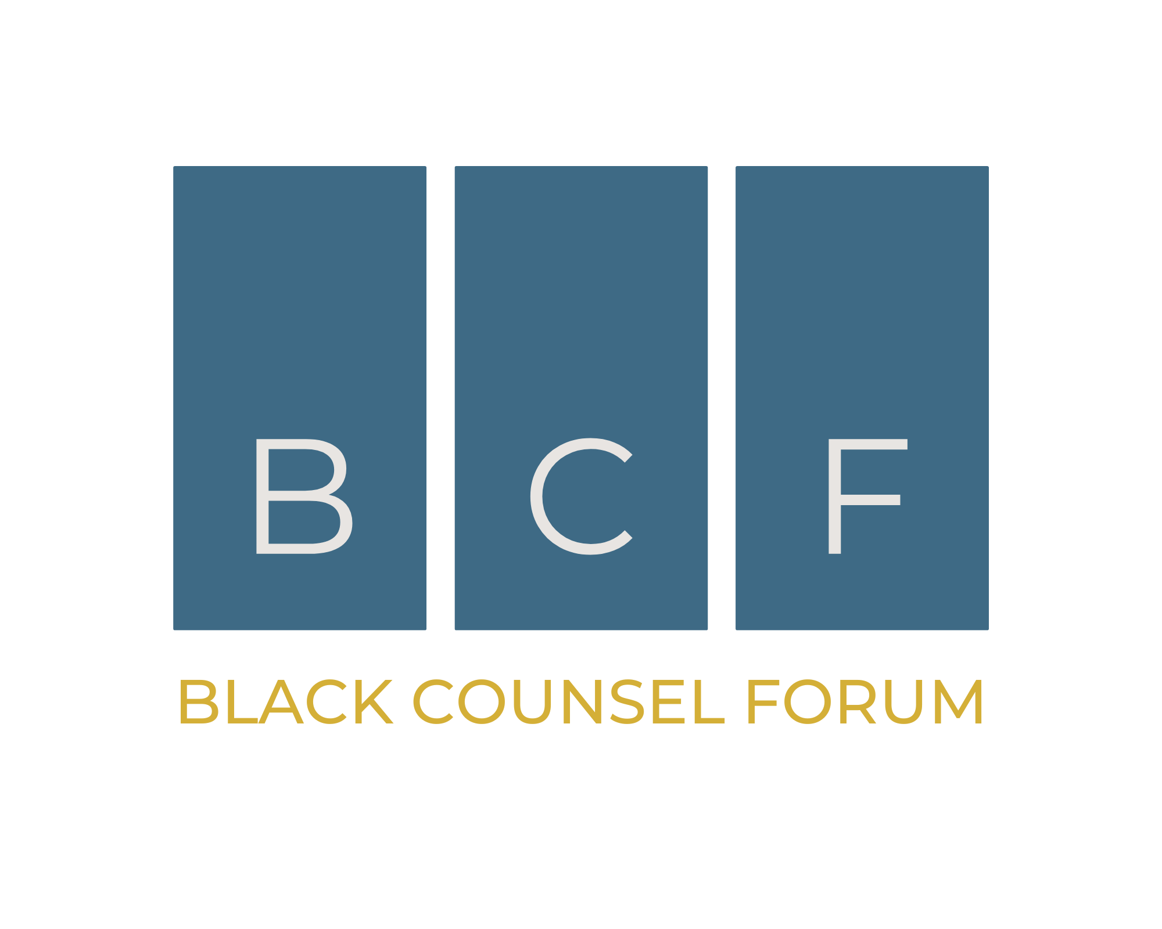
Application for Funding/Justification Letter: Attendance at BCF24

Dear [Supervisor/Manager's Name],

I hope this message finds you well.

I am writing to request approval for professional development funding to attend the Black Counsel Forum 2024 (BCF24), a pivotal careers conference scheduled to take place at De Vere Beaumont Estate in Old Windsor on Friday, September 27th, and Saturday, September 28th, 2024. This two-day residential conference is uniquely designed to cater to the needs of Black lawyers, aiming to inspire, energise, and empower them with the necessary tools, knowledge, and support essential for excelling in their respective careers.

Upon thorough review of the conference's objectives and offerings on its official website, www.blackcounselforum.com, I learned that BCF24 will gather up to 400 of the most distinguished Black legal professionals from across the nation, spanning various practice areas and levels of expertise. The attendees will range from trainees to partners, junior counsel to General Counsel, and pupil barristers to Kings Counsel.

BCF24 boasts a diverse panel of accomplished lawyers, esteemed speakers, and engaging masterclass courses, all of which I anticipate will significantly enhance my professional capabilities and equip me with valuable knowledge and strategies applicable to our team's endeavours. Attending this conference presents an invaluable opportunity for me to gain insights, learn best practices, and foster connections with prominent Black lawyers and peers from throughout the UK. Furthermore, I am committed to providing a comprehensive report highlighting key takeaways and actionable recommendations tailored to benefit our team and align with our organisational objectives.

To gain a deeper understanding of the Black Counsel Forum and its potential impact on both my professional growth and our company's goals, I encourage you to explore the official website, where you will find video footage and programs from past BCF conferences.

It is worth noting that the conference is being sponsored by reputable firms and companies, including Slaughter and May, Goodwin Proctor, and HSBC.

The discounted Early Bird Registration fee of £595 + VAT covers access to all masterclasses, panel discussions, keynotes, networking opportunities, and accommodation at the conference venue. Please be aware that Early Bird tickets are limited in availability.

I kindly request your approval for funding to secure my attendance at this event. Your support in this endeavour would be greatly appreciated and undoubtedly contribute to my ongoing professional development.

Thank you in advance for considering my request. Should you require any additional information or clarification, please do not hesitate to contact me.

Best regards,

[Your Name]

